

Project Title:

**Sign Language Translator for Speech-impaired**

Submitted by:

**Noor-ul-Emaan (2020-CE-33)**

**Hareem Arshad (2020-CE-34)**

**Hira Sohail (2020-CE-41)**

**Palwasha Ali (2020-CE-48)**

Submitted to:

**Sir Raja Muzammil**

Course:

**CMPE-341L Artificial Intelligence**

Semester: **Fall 2022**

Date:

**October 24, 2022**

**Department of Computer Engineering**

**University of Engineering and Technology, Lahore**

**Table of Content**

**Abstract………………………………………………………………………….. 3**

**Introduction……………………………………………………………………… 3**

**Problem Statement………………………………………………………………. 4**

**Explanation………………………………………………………………………. 4**

**Technology to be used…………………………………………………………… 4**

**Dataset……………….…………………………………………………………… 5**

**Python Libraries To be used……………………………………………………. 5**

**Algorithms to Be used…………………………………………………………… 5**

**SVM………………………………………………………………………………. 5**

**HOG………………………………………………………………………………..6**

**GUI…………………………………………………………………………………6**

**Video Features……………………………………………………………………..7**

**Application…………………………………………………………………………7**

**References………………………………………………………………………….7**

**Abstract:**

There has always been a major problem of communication between special people and normal people. Sign Language Converter is a program developed to detect the hand signs and then convert them into short English sentences as well as it can convert the text into sound which also helps the user to understand the text in a much better way. The main purpose or the background of this program is to help deaf and dumb people. It can help them to understand the text written on the screen just by making different hand gestures. By using different hand conditions a whole language for those people can be developed and serve humanity.

**Introduction:**

Sign language translation (SLT) is an important application to bridge the communication gap between deaf and hearing people. Normal people will find it difficult to communicate with hearing-impaired people. To break the barrier of communication between normal and hearing-impaired people, the Speech to Sign Language translator is used. This translator makes the interaction simpler and faster for normal people to convey their ideas to hearing impaired people. The translator converts speech or text to Sign Language using Natural Language Processing algorithms. Thus, the system is used to overcome the hurdles faced by normal people to share their thoughts with hearing impaired people and it will be an ear for the hearing-impaired.

Gesture is a symbol of physical behavior or emotional expression. It includes body gesture and hand gesture. Gesture recognition determines the user intent through the recognition of the gesture or movement of the body or body parts. Hand gesture recognition has great value in many applications such as sign language recognition, augmented reality (virtual reality), sign language interpreters for the disabled, and robot control.

In this project, we will use an efficient and effective method for hand gesture recognition. The hand region is detected through the background subtraction method. Then, the palm and fingers are split so as to recognize the fingers. After the fingers are recognized, the hand gesture can be classified through a simple rule classifier.

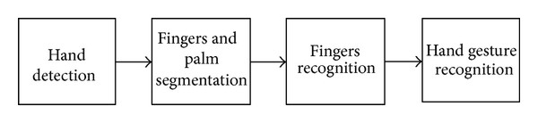

Figure 1

**Problem statement:**

To develop Application that will be helpful in communication between special people and normal people.

**Explanation:**

We will develop the program by putting it into different parts. In the first part, we will use OpenCV and media pipe to detect the movement of the hand and display it on the screen using the webcam of the computer.

We will made functions for the better understanding of code and this function will help to convert the picture into the respective RGB color and will implement all the conditions for hand gestures which the program will show on the output window.

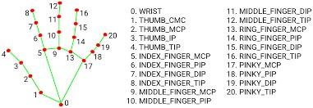

Figure 2

It will show 21 different landmarks point plotted on hands and with their help, track of the movement of the hand will be quickly recorded. On any finger, there are two possibilities either a point is greater or smaller in the respective x and y planes. If we take one example of the index finger as you can see **lm_list[8].y < lm_list[6].y**in the snippet it means that the point 6 is greater than the point 8 which means the finger is open state and there is no fold in it but if we change the condition to**lm_list[8].y >lm_list[6].y**which means now point number 8 is greater if the finger is closed or in the folded state. Like this, we can write the conditions for all of the fingers and implement all the conditions. Here lm_list represent landmark list.

**Dataset:**

We will take videos to understand the position of hand and fingers to train our model as a reference from a website. Its link is given in reference heading

Suppose a person has 2 fingers mold and thumb is upward it would be a sign of gun. We will train the model with algorithm and programming by using the conditions and svm algorithm. X and y position of landmark points will be used.

We will define the conditions of x y points. We will atleast train the model with 30 signs i-e 30 conditions.

**Technologies to be used:**

* Python
* AI machine learning algorithm and searching techniques

**Different libraries of Python to be used:**

* OpenCV
* MediaPipe
* Tkinter

**Implementation of AI Algorithm**

**SVM Algorithm:**

SVM is a machine learning algorithm belonging to the supervised learning group. It is used in classification or regression problems. It is a binary classification algorithm. The SVM takes the input and classifies them into two different classes. SVM training algorithm builds a model to classify them into those two categories.

The idea of SVM is to find a hyperlane to separate data points. This hyperplane will divide the space into different domains and each domain will contain a type of data. For example, we have a dataset of blue and red points placed on the same plane.

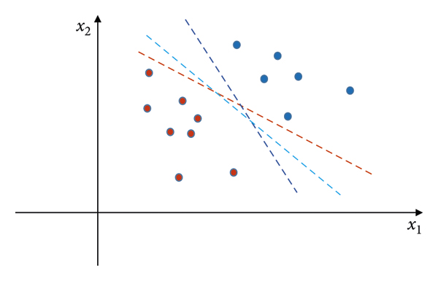

Figure 3

**HOG Algorithm:**

The typical HOG idea comes from the object of form and state. It can be characterized by the intensity and direction distribution of pixel value and is represented as a vector calling a gradient vector. Gradient is a vector of elements that represent how fast a pixel of value changes. The gradient vector value brings a lot of useful information. It represents the change in the luminance value of pixels. The gradient vector value changes when the pixel is in the corner and edge areas of the object. Therefore, the HOG feature is effective in choosing the representation of posture.

We will compute a histogram of directions of gradients for points for each cell. To combine the histograms together, we get a representation of the original image. To enhance recognition performance, local histograms can be normalized for contrast by calculating an intensity threshold in an area larger than the cell calling blocks. We will use the threshold value to normalize all cells in the block.

It will convert the information from SVM to NLP so that it would be easy to train machine.

**GUI** **(Graphical User Interface)**

To make this whole program user friendly and to give a new dimension to it. We will implement GUI in the program, including following features:

* Drop Down Menu
* Message Box(current status)
* Voice Enabling
* Buttons and label

# Video Feature:

In this program, we will add a feature for user convenience that they can switch between live cameras or run any video from the computer hence all the logic of the program will be implemented on that video.

**Applications:**

* The translator will make interaction simpler and faster for normal people to convey ideas to deaf people.
* The main application of this project is to provide aid for the speech-impaired
* Due to the simplicity of the model, it can also be implemented in smartphones and is regarded as our future plan to do so.

**References**

[1]. https://mediapipe.dev/index.html

[2]. https://google.github.io/mediapipe/solutions/hands

[3]. https://docs.opencv.org/4.x/index.html

[4]. https://www.youtube.com/watch?v=01sAkU_NvOY

[5]. <https://www.youtube.com/c/MurtazasWorkshopRoboticsandA>

[6]. <https://www.scienceofpeople.com/hand-gestures/>